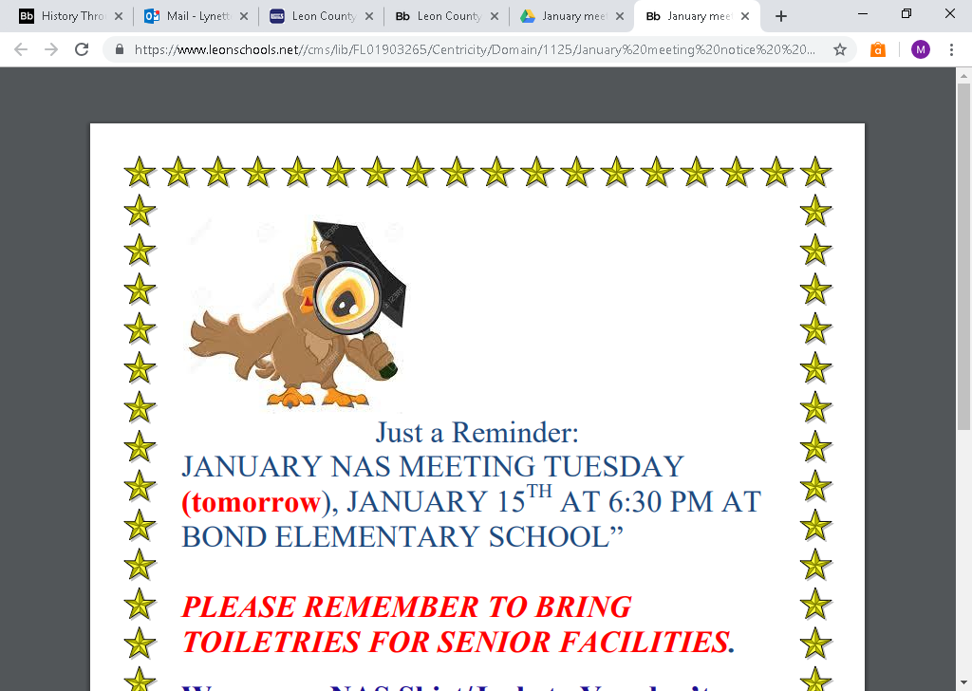

Hello NAS Family:

APRIL MONTHLY MEETING

MONDAY, APRIL 1, 2019

**TIME:** 6:30 PM

**LOCATION**

BOND ELEMENTARY SCHOOL – CAFETERIA

**THIS IS THE MONTH WE NOMINATE OFFICERS FOR**

**2019-2020 SCHOOL YEAR.**

IF THERE ARE ANY QUESTIONS PLEASE FEEL FREE TO CONTACT

DR. JACKSON-JAMES AT 850-544-0745 OR [JAMESM@LEONSCHOOLS.NET](mailto:JAMESM@LEONSCHOOLS.NET)